**Canberra Health Services**

**Procedure**

**Respiratory Protection Program**

|  |
| --- |
| Contents |

Contents 1

Purpose 2

Scope 2

Roles and Responsibilities 3

Section 2 – Respirator use within CHS 6

Section 3 - Education of Workers 6

Section 4 – Inclusion and Exclusion Criteria for Fit Testing 7

Section 5 – Fit Testing Schedule 9

Section 6 – Respirator Fit Testing 10

Section 6 – Fit Checking 12

Evaluation 12

Definition of Terms 13

Related Policies, Procedures, Guidelines and Legislation 14

References 15

Search Terms 15

Attachments 16

Attachment 1 – Competency Assessment Tool 17

|  |
| --- |
| Purpose |

The purpose of this procedure is to describe Canberra Health Services (CHS) Respiratory Protection Program (RPP) and inform workers how to access the RPP, including:

* Guidance on fit testing and selection of appropriate respiratory protection devices (RPDs) for workers. Single use N95/P2 Respirators are used in patient facing roles across CHS facilities.
* Guidance on fit testing reusable respirators, which are used by the medical physics staff only.
* Education and advice on the intended use of the RPD.
* What is required to ensure they are managed, worn, and used safely to minimise the risk of exposure of a respiratory hazard/s.

CHS has an obligation under the *Work Health and Safety (WHS) Act 2011* to provide a safe and healthy environment for all CHS workers, volunteers, patients, contractors (and their workers) visiting CHS owned or operated facilities and buildings, as well as visitors to the hospital facilities, sites, and community service areas under our management.

The *WHS Act 2011* requires CHS to manage health and safety risks. This is achieved by the elimination where reasonably practicable, and where elimination is not practicable through the minimisation of risks.

Additionally, the *Australian Guidelines for the Prevention and Control of Infection in Healthcare*, and the *National Safety and Quality Health Service Standard on Preventing and Controlling Healthcare Associated Infection* require an RPP to be in place to protect workers from healthcare associated infections.

The development of the RPP is in line with *NSW Clinical Excellence Commission (CEC) Guidelines*.

*Back to Table of Contents*

|  |
| --- |
| Scope |

This procedure applies to CHS workers (clinical, non-clinical and students) who are at risk of exposure delivering care to patients with a suspected or confirmed respiratory infection or communicable disease with potential for airborne transmission.

**The requirement for a RPD includes workers who:**

* Deliver care to patients in high-risk areas with suspected, probable, or confirmed respiratory infection or communicable diseases with potential for airborne transmission (e.g., pulmonary, or laryngeal tuberculosis [TB], measles, COVID-19).
* Perform a respiratory aerosol generating procedure (AGP) on a patient with suspected, probable, or confirmed respiratory infection (e.g., COVID-19) or undertaking clinical work within this space.
* Clean a room or zone after a respiratory AGP on a suspected, probable, or confirmed respiratory infection or communicable diseases with potential for airborne transmission.
* Use toxic metals such as lead used in the radiation oncology mould room. Example: Medical Physics staff.

**High risk areas include:**

* Intensive Care Unit (ICU) (adult, paediatric/neonatal)
* Emergency Department (ED)
* Operating theatres where intubation/extubating, bronchoscopy or other respiratory AGPs are being performed
* Maternity Birthing Suite
* Wards that will provide inpatient care to patients with suspected, probable, or confirmed respiratory infection or communicable diseases with potential for airborne transmission, including those with negative pressure rooms or respiratory isolation rooms
* Radiation oncology mould room.

**High risk workers include:**

* Healthcare workers (HCW) who have exposure to patients with infectious respiratory diseases
* HCW performing aerosol generating procedure (AGP) on patients, residents, or clients
* Emergency responders e.g., MET (Medical Emergency Team) and HERO (Hospital Emergency Response Officer) and any other staff identified as being at high risk of exposure
* Ancillary/support staff (e.g., cleaners) who are required to enter a negative pressure room or rooms used for AGPs
* Medical Physics staff working in the radiation oncology mould room.

This document does not apply to surgical masks or powered air-purifying respirators (PAPR).

*Back to Table of Contents*

|  |
| --- |
| Roles and Responsibilities |

All workers should be aware of and remain compliant with this procedure. Staff responsibilities under this procedure are outlined below:

**Employees/Workers:**

* Declare any medical reason (including physical and psychological reasons) that they believe prevent them safely being fit tested/or wearing a RPD.
* Ensure they are free of facial hair each time they are wearing a tight-fitting respirator unless they have a religious or medical exemption:
  + For information regarding approved facial hair styles (*Section 5* of this procedure)
  + The REST-FIT board position statement December 2021: All international standards, including AS/NZS 1715:2009, ISO 16975-3, OSHA 1910.134 and others, clearly state that there should be no facial hair on a wearers’ face underneath a tight-fitting respirator sealing surface area and they therefore to not support any beard covering techniques.
* Attend respirator fit testing as required under this procedure and/or directed by their manager and any pre-requisite learning required.
* Be aware of their individual fit testing outcomes.
* Use, maintain, and dispose of respirators properly in accordance with training and local procedures in line with mandatory training CHS personal protective equipment.
* Conduct a fit check of a respirator, every time one is used.
* Discuss any concerns with respirator use or supply to their supervisor or Manager.

**Supervisors/line managers:**

* Ensure all potential exposures to respiratory hazards, including exposure to aerosol transmissible pathogens, have been identified, risk assessed, and workers have been provided with the correct RPD.
* Ensure that workers who require RPD are identified.
* Ensure that this procedure is implemented in the work area.
* Ensure workers are provided an opportunity to attend the required training and scheduled fit testing.
* Liaise with worker and HR Business Partner (HRBP) to manage workers who are unable to be fit tested or wear RPD.
* Ensure that records of respirator training are documented in HRIMS.
* Discuss any concerns with respirator use or supply to their manager.

**Unit Managers**:

* Ensure this procedure is implemented within their areas.
* Ensure that hazards/risks are identified and managed in consultation with their workers, work areas, and WHS.
* Ensure WHS risk assessments are undertaken across their work areas to identify workers who require respiratory protection.
* Provide adequate resourcing to ensure the RPP continued effectiveness.
* Identify workers eligible for priority fit testing.
* Ensure that training and PPE resources are available to allow compliance with this procedure.
* Undertake periodic spot checks of workers to ensure they are donning and doffing correctly and remain clean shaven when wearing respirator in high-risk settings.
* Discuss any concerns with respirator use or supply with the Supply team or the appropriate Executive.

**Executives:**

* Ensure that a process is in place to allow the RPP to be implemented.
* Ensure that all required resources are available for the implementation and ongoing management of the RPP.

**CHS Respiratory Protection Program Lead, Occupational Medicine Unit:**

* Coordinate the fit testing schedule and collaborates with the ‘fit testers’ to perform the scheduled fit testing.
* Engage in regular education and upskilling processes.
* Coordinate training for fit test assessors.
* Ensures monitoring and reporting of competency assessments of fit test assessors is completed annually.
* Facilitates the maintenance of records relating to fit testing.
* Facilitates the maintenance of fit testing equipment and consumables related to fit testing.
* Provides reports on fit testing outcomes to the Infection Prevention and Control Clinical Response Committee and the Peak Work Health Safety Committee on a quarterly basis.
* Liaise with the Clinical Nurse Consultant (CNC) Occupational Medicine Unit (OMU) to provide reports on fit testing results to Work Health Safety, Divisional Executive Director and the Infection Prevention Control Clinical Response Committee
* Any other relevant duties assigned by the department to support effective management of the RPP.

**Fit Test Assessor:**

* Maintains competency in performing Fit Testing Program.
* Engage in regular education and upskilling processes.
* Complete Fit Testing as per best practice guidelines.
* Maintains records relating to fit testing.
* Maintains fit testing equipment and consumables related to fit testing.
* Provides reports on fit testing outcomes to workers.
* Liaises and escalates issues to the RPP Lead.

**CHS Product Consultant and CHS Supply must ensure:**

* There is a sustainable supply of suitable respirators that meet the requirements of CHS workers.
* Respirators stocked at CHS meet Australian Standards.
* Respirators stocked meet CHS Infection Prevention and Control policies and procedures and WHS requirements.

**Contractors**

The use of respiratory protection devices by contractors working on CHS sites will be managed by CHS Contracts Management team. It remains the responsibility of the Contractor to ensure the appropriate respiratory protection is provided to workers, is clean and maintained and is fit for purpose. The CHS Contract Manager is responsible for engaging the services of the contractor to provide oversight and ensure that appropriate respiratory protection is provided to workers, is clean and maintained and is fit for purpose.

*Back to Table of Contents*

|  |
| --- |
| Section 2 – Respirator use within CHS |

**Respiratory Protective Devices**

Single use N95/P2 respirator masks are the preferred type of respirator protection at CHS. Defective disposable respirators are to be replaced immediately and if used, discarded as per doffing practices. Isolation and notification of defect supply is to be reported to the relevant line manager through existing communication protocols. Escalation to the CHS Product Consultant, via switchboard, will be required for ongoing and/or bulk defect circumstances.

**Voluntary Use of Respirators**

When the use of a respirator is not required and a risk assessment has determined that its use is not necessary, a worker may still request to use a respirator voluntarily. Workers using respirators voluntarily will be included in the RPP.

**Clinical Environments**

The supervisor/line manager will review and update the risk assessment any time a worker or supervisor identifies or anticipates a new exposure or variations to existing exposures occurs because of any changes to practice or operating conditions.

*Back to Table of Contents*

|  |
| --- |
| Section 3 - Education of Workers |

Education and training are essential components of minimising HCW exposure to respiratory hazards. Where a RPD is to be used, education and training must be provided by a competent person on its safe use and limitations of the RPD selected. This training should be provided routinely with training provided to users when they are required to use new and/or different forms of RPD (including assorted brands, models etc.).

**Training principles:**

* Workers are to complete the CHS Personal Protective Equipment e-learning, prior to attending their appointment.
* Workers are expected to be able to demonstrate knowledge of proper use of RPD. This can be done through reviewing training either orally or in writing and by reviewing workers use in a safe and controlled environment. It is essential that training for workers has a specific healthcare setting focus on how a respirator, in combination with other PPE requirements reduces the risk in recognised and unrecognised sources of airborne and aerosolised infectious agents in healthcare settings.

**Training should occur:**

* before first respirator use
* annually
* when there is a change in the type of respiratory protection used
* if gaps are identified in HCW knowledge and skills assessment.

**Training will:**

* be provided prior to the commencement of use of the RPD
* name the work areas and/or tasks where RPD is required
* explain the type of RPD for use
* explain the importance of proper fitting
* demonstrate how the RPD is to be donned, doffed, and disposed
* demonstrate a fit check
* explain the limitations of the RPD selected
* describe maintenance and storage requirements (if relevant)
* be repeated regularly, e.g., at least annually, and improve supervisor’s knowledge of RPD so they can ensure that RPD is used effectively by staff under their management.

*Back to Table of Contents*

|  |
| --- |
| Section 4 – Inclusion and Exclusion Criteria for Fit Testing |

Staff whose work activities require the use of a respirator must be physically and psychologically fit to participate in the fit testing program and the wearing of the respirator.

CHS has developed priority groups of workers who require fit testing to ensure workers with the highest risk are prioritised for fit testing.

|  |  |  |
| --- | --- | --- |
| **Risk Category** | **Worker Category** | **Clinical Area** |
| 1 | Clinical staff allocated to a Resuscitation/Intubation  Team  Clinical staff required to perform an Aerosol Generating Procedure (AGP) on a patient, suspected or confirmed with COVID-19  Medical Physics | Anaesthetics  Emergency Department  Intensive Care Unit  Operating or Procedure Rooms where Bronchoscopy or other AGPs are performed.  Other clinical groups performing or assisting with intubations or resuscitations.  Any staff working in medical physics who routinely work in the radiation oncology mould room. |
| 2 | Critical care clinicians  Staff (clinical & non-clinical) allocated to COVID-19 care teams or wards/floors | Coronary Care Unit  Designated COVID-19 units, wards, or floors |
| 3 | Clinical staff providing direct care or procedural support to patients requiring airborne precautions.  Note: some HCWs may be duplicated - diseases requiring airborne precautions includes Tuberculosis, Measles, Varicella or emerging pathogens and any other diseases for which public health guidelines recommend airborne precautions.  Ancillary staff (e.g., cleaners) who are required to enter a negative pressure room or the room of a patient requiring airborne precautions. | All clinical areas |
| 4 | Staff (clinical & non-clinical) in other patient care areas identified as risk for airborne transmissible disease exposure. | Any other area |

**Workers who do not require fit testing:**

* Administration staff who are not working in a clinical environment, e.g., Divisional Executive Offices.

**Workers who have completed fit testing can be retested if there is:**

* A change in Personal Protective Equipment (PPE).
* No supply or discontinuation of workers preferred respirator and at fit testing no other respirators identified as suitable.
* Physical changes that could affect respirator fit. These changes include, but are not limited to, facial scarring, dental changes, facial surgery, or an obvious change in body weight, face shape or facial hair.

**Workers who may be unable to use respirators or participate in Fit Testing**

Workers who cannot participate in fit testing due to medical reasons require a medical certificate to obtain an exemption. Workers who cannot participate in fit testing because they have facial hair for religious or cultural reasons must notify and discuss this with their manager. For both the above, the manager in consultation with the RPP lead and divisional HRBP, should consider the following options to ensure that the worker remains safe:

Option 1 - use a risk management approach to ensure that the worker is not exposed to a foreseeable situation in which a respirator would be required,

OR

Option 2 - relocate the worker to another work area where respirator use is not required in carrying out normal work tasks for that area.

*See Attachment 1 in this procedure for Fit Test Flow Process for a failed fit test*.

*Back to Table of Contents*

|  |
| --- |
| Section 5 – Fit Testing Schedule |

* New workers should be fit tested during on boarding to CHS.
* CHS will accept a fit test result less than12 months old from a recognised RPP. This will be assessed by the RPP program lead.
* For students, the clinical placement office will be responsible for advising OMU and the student of their risk category and Fit Testing requirements.
* Prioritisation will be based on workers risk category as per Section 4 of this procedure.
* Existing workers should be tested.
* Retesting is required where there has been a change in RPD availability – size, style, model or make or where a new make/ model is issued.
* Retesting is required when there is a change in the wearer's facial characteristics, e.g., loss of teeth/dentures or excessive changes in weight (including pregnancy) or facial surgery.
* Appointments for Fit testing can be made by contacting OMU and scheduling an appointment on 5124 2321 or emailing [CHS.FitTesting@act.gov.au](mailto:CHS.FitTesting@act.gov.au)

*Back to Table of Contents*

|  |
| --- |
| Section 6 – Respirator Fit Testing |

Fit testing is a validated process of determining the type and size of respirator that achieves an adequate seal on an individual’s face. Although there are several published studies that show that fit testing will detect air leakage in respirators that have passed a fit check, the evidence showing that fit testing reduces risk of infection in workers is currently limited and equivocal. Despite this, Australian and New Zealand Standards 1715:2009 and current national opinion and consensus recommends fit testing for workers working in high-risk areas when providing care to patients with suspected or confirmed COVID-19 or patients under airborne precautions.

CHS will undertake **Quantitative fit testing** as part of its RPP. A Quantitative Fit Test requires the use of specialised particle counting equipment (PortaCount™ Fit Testing device) to provide quantitative, or numerical, measurements of the amount of face seal leakage present when a given respirator is donned by a particular user.

**Fit factor:**  
A Quantitative Fit Test generates a number that is referred to as the Fit Factor (FF). The FF is a measure of how well a facepiece seals against the wearer's face. A higher FF number (e.g., disposable filtering facepiece with 100+) means the facepiece achieved good contact between the face seal and the face during the test.

**Who can conduct respirator Fit Testing?**

Fit testing is to be carried out by RPP staff that have been trained and assessed as competent, as per *Attachment 4* in this procedure.

**Fit Testing Procedure**

Refer to *Attachment 2* of this procedure Fit Test Checklist for a quick guide of the steps the Fit Test Assessor will complete during fit testing

* Workers to bring any special/specific PPE they wear at work (e.g., glasses) to the testing appointment so they can be worn during testing ensure they do not interfere with the face piece seal, and that the respirator does not interfere with their visual field.
* Workers are to adjust or modify their hair, facial hair, and any adornments to accommodate the fit testing requirements. (*See Figure 1 below*)

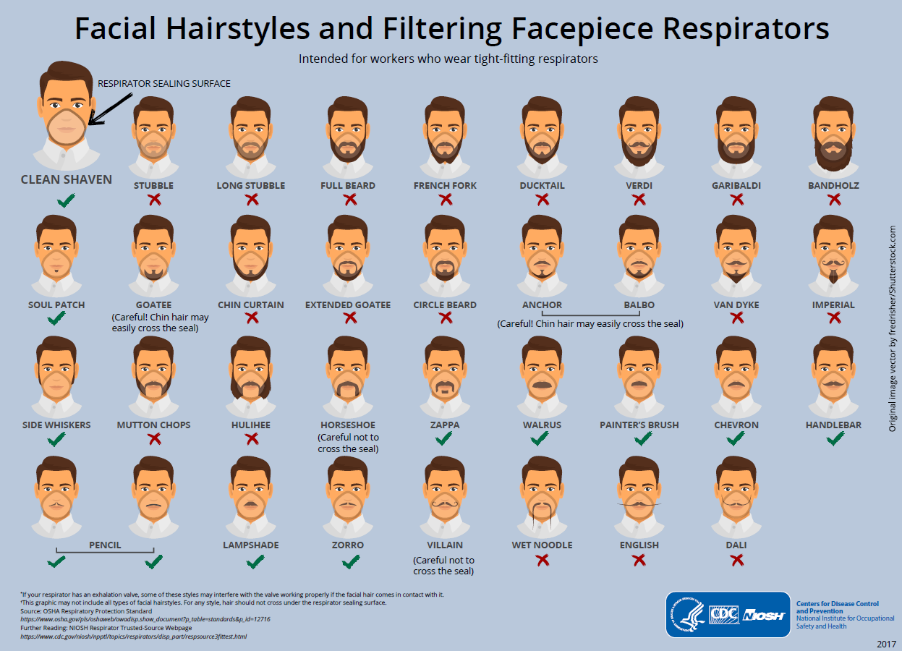

*Figure 1: Facial Hairstyles and Filtering Facepiece Respirators Centres for Disease Control and Prevention 2017*

* HCWs will be offered a selection of several models and sizes of respirators that are readily available within CHS.

**Alert:** If at any time the worker becomes short of breath, dizzy or uncomfortable during fit testing, the test will stop.

**Workers who fail to achieve a pass level Fit Factor**

Should a worker fail to achieve the required FF for all available types, brands, and sizes of disposable respirator available, the RPP lead will notify the relevant manager. The manager in consultation with the RPP lead and HRBP, should consider the following options to ensure that the worker remains safe:

* Option 1 - use a risk management approach to ensure that the worker is not exposed to a foreseeable situation in which a respirator would be required, or
* Option 2 - relocate the worker to another work area where respirator use is not required in carrying out normal work tasks for that area

*Back to Table of Contents*

|  |
| --- |
| Section 6 – Fit Checking |

A fit check is different to a fit test. Both fit tests and fit checks are individual elements of an RPP. A fit check must be undertaken each time a respirator is donned.

Either the positive and negative pressure checks (huff and puff), or the respirator manufacturer's recommended user fit check method should be used. User fit checks are not substitutes for fit testing. Fit checks must be undertaken even if fit testing has been completed on the same brand of respirator.

**Fit checking is required:**

* Each time a disposable P2/N95 or reusable respirator is worn
* Before fit testing
* For assessment of mask fit.

**Fit Check Training:**

Fit check training will occur at minimum, during initial fit testing appointment and during annual competency or skills assessment.

The training will include:

* Why the respirator is necessary and how proper fit, usage, and maintenance can ensure the protective effect of the respirator as well as how improper fit, usage or maintenance can compromise the protective effect of the respirator.
* The limitations and capabilities of the respirators that will be used.
* How to inspect, don, doff and check the seals of the respirator (i.e.N95/P2 masks).
* How and when to safely dispose of a respirator that has possibly or certainly been contaminated.

*Back to Table of Contents*

|  |
| --- |
| Evaluation |

**Outcome**

Workers at CHS who require respirators to protect themselves while performing work duties where respiratory pathogens and toxic metals are present are managed as per this procedure.

**Measures**

* A review of feedback obtained from employees (to include respirator fit, selection, use, and maintenance issues) will be provided to the RPP Lead, Fit Test Assessor or OMU, CNC.
* Reporting of fit testing data completed per division, number completed tests and results of pass or fail percentage will be forwarded to the Secretariat of CHS Peak WHS Committee ([chs.workhealthsafety@act.gov.au](mailto:chs.workhealthsafety@act.gov.au)) and Infection Prevention and Control Clinical Response Committee on a quarterly basis
* Auditing of fit tests completed including the following information:

Passes versus fails.

* How many workers can wear more than one type of mask.
* Numbers of workers who attend a fit test with facial hairstyles incompatible to the fit testing process.
* Auditing Fit Checking procedures
* Surveillance of staff’s knowledge of fit testing and accurate use of their respirator

*Back to Table of Contents*

|  |
| --- |
| Definition of Terms |

**Aerosol:** is a mist composed of exceedingly small, lightweight particles that can remain suspended in the air for extended periods of time and can travel long distances. These particles can penetrate the lower parts of the respiratory system and are <5 microns in diameter.

**Aerosol-Generating Procedures (AGP):** AGP procedures that are more likely to generate higher concentrations of respiratory aerosols than coughing, sneezing, or breathing. Includes procedures such as bronchoscopy, tracheal intubation, non-invasive ventilation etc.

**Airborne transmission:** is the spread of an infectious agent caused by the dissemination of droplet nuclei (aerosols) that remain infectious when suspended in air over long distances and time.

**Droplet transmission:** is when a person is in close contact (within 1.5 metres) with an infected person who has respiratory symptoms (e.g., coughing or sneezing) or who is talking or singing; in these circumstances, respiratory droplets that include virus can reach the mouth, nose or eyes of a person and can result in infection.

**Fit check (user seal check):** is a process of ensuring Respiratory Protection Device (RPD) achieves a good seal once it has been applied and should occur each time RPD is donned, even if fit testing has previously been undertaken.

**Fit test:** is a validated method of matching RPD to an individual. CHS have adopted the quantitative method;

* A quantitative fit test requires the use of specialised particle counting equipment (such as a PortaCount™ or a AccuFit™ Fit Testing device) to provide quantitative, or numerical, measurements of the amount of face seal leakage present when a given respirator is donned by a particular user.

**Healthcare Worker (HCW):** for the purposes of this document includes all CHS staff. This includes registered health practitioners, self-regulated health practitioners, diagnostic, administration, food services and ancillary staff.

**P2/N95 Respirator:** is a medical device designed to protect the wearer from infectious aerosols generated directly from the patient or created during aerosol-generating procedures e.g., bronchoscopy. The respirators used in healthcare settings can filter out approximately 94% of particles <5 microns in size and are known in Australia as P2 respirators (equivalent to N95 in USA or FFP2 in the UK).

**Respiratory Protective Device (RPD):** a RPD is equipment designed to protect the wearer and prevent the inhalation of contaminated air (e.g., P2/N95 respirator/mask).

**Single use surgical mask (levels 1, 2 or 3 barrier):** is a loose-fitting, single-use, fluid resistant disposable mask that creates a physical barrier between the mouth/nose of the wearer and direct droplet spray, as well as reducing the spread of respiratory droplets from the wearer. Single use surgical masks are not designed to provide respiratory protection to the user. They are designed to reduce the spread of infection from the user to other people and provide limited respiratory protection to the wearer against aerosols.

*Back to Table of Contents*

|  |
| --- |
| Related Policies, Procedures, Guidelines and Legislation |

**Policies**

* Nursing and Midwifery Board of Australia (NMBA) Requirements for Practice
* Work Health and Safety
* Informed Consent (Clinical)
* Preventing and Controlling Healthcare Associated Infections

**Procedures**

* Infection Prevention and Control

**Guidelines**

* NSW Health Clinical Excellence Commission - Respiratory Protection in Healthcare version 1.2 October 2022

**Legislation**

* *Health Records (Privacy and Access) Act 1997*
* *Human Rights Act 2004*
* *Work* *Health and Safety Act 2011*

**Other**

* Australian Charter of Healthcare Rights

*Back to Table of Contents*

|  |
| --- |
| References |

1. *NSW Health Clinical Excellence Commission, 2021. Respiratory Protection in Healthcare version 1.2, October 2022, accessed at:* <http://www.cec.health.nsw.gov.au/__data/assets/pdf_file/0006/597687/Respiratory-Protection-in-Healthcare.pdf>
2. *Australian Institute of Occupational Hygienists (AIOH), 2021*, [AIOH – Australian Institute of Occupational Hygienists](https://www.aioh.org.au/)
3. ***Standards Australia and Standards New Zealand 2009 AS/NZS 1715:2009, Australian/New Zealand Standard*** *Selection, use and maintenance of respiratory protective equipment. Sydney NSW*.
4. ***Standards Australia and Standards New Zealand 2012. AS/NZS 1716:2012, Australian/New Zealand Standard R****espiratory protective devices. Sydney NSW*
5. *TSI® incorporated, 2015, PortaCount Pro Respirator Fit Tester Operation and Service manual. Accessed at:* <https://tsi.com/getmedia/76df3dbb-6d8d-4d78-aa24-5aff19e889e9/8030_8038_PortaCountPro_Manual_6001868?ext=.pdf>
6. *TSI**® Incorporated, 2020. Official Response to Questions Related to use of the PortaCount Respirator Fit Tester during a Pathogenic Outbreak. Accessed at*: <https://conceptcontrols.com/media/wysiwyg/pdf/TSI%20FAQ%20-%20Portacount%20Use%20During%20Pandemic%20-%20RFT-032B.pdf>
7. *TSI® Incorporated 2020. Hygienic Security and the PortaCount Respirator Fit Tester Application Note ITI-034 Rev.D (US). Accessed at*: [https://www.kenelec.com.au/wp-content/uploads/2018/04/TSI-ITI-034-Hygienic-Security-and-the-PortaCount-Respirator-Fit-Tester-AppNote.pdf Accessed on 22/09/21](https://www.kenelec.com.au/wp-content/uploads/2018/04/TSI-ITI-034-Hygienic-Security-and-the-PortaCount-Respirator-Fit-Tester-AppNote.pdf%20Accessed%20on%2022/09/21)

*Back to Table of Contents*

|  |
| --- |
| Search Terms |

Fit Testing, Fit Checking, mask, respirator, N95, P2, COVID, COVID-19, SARS-CoV2, Respitatory, Respiratory Protection Program, RPP

*Back to Table of Contents*

|  |
| --- |
| Attachments |

Attachment 1 – Fit Testing Process Flow

**Disclaimer**: *This document has been developed by Canberra Health Services specifically for its own use. Use of this document and any reliance on the information contained therein by any third party is at his or her own risk and Canberra Health Services assumes no responsibility whatsoever.*

*Policy Team ONLY to complete the following:*

|  |  |  |  |
| --- | --- | --- | --- |
| *Date Amended* | *Section Amended* | *Divisional Approval* | *Final Approval* |
| *06/10/2023* | *New Document* | *Kellie Lang, ED NMPSS* | *CHS Policy Committee* |
|  |  |  |  |

*This document supersedes the following:*

|  |  |
| --- | --- |
| *Document Number* | *Document Name* |
|  |  |
|  |  |

# **Attachment 1 – Fit Testing Process Flow**

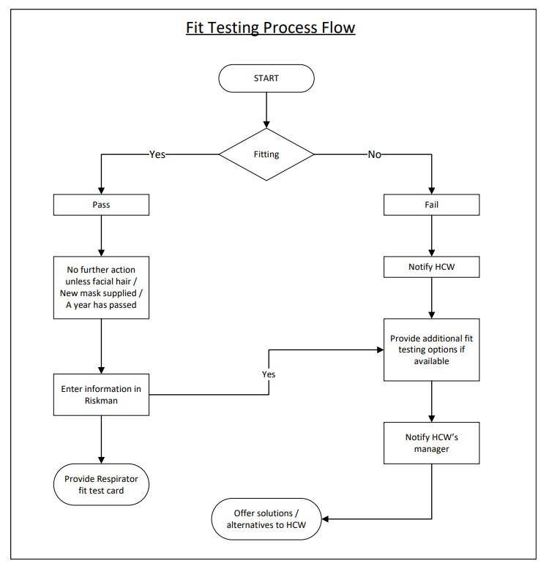

Note: The staff member must notify their manager of failure of a fit test. Options for "additional fit test" must be limited to a single reattempt. If you fail a fit test more than twice - then accept that the result is a failure.