**Procedure** | Canberra Health Services

Aseptic Technique  
CHS24/595

**Contents**

Purpose 2

Alerts 2

Scope 2

Section 1 – Training and Competency Requirements 3

Section 2 - Background 4

Section 3 – Core Principles of Aseptic Technique 4

Section 4 – Sterile Item/ Stock Management 10

Section 5 – Preparing and Managing the Aseptic Field 10

Evaluation 12

Related policies, procedures, guidelines and legislation 13

References 14

Definition of terms 15

Search terms 16

Attachments 16

## Purpose

The purpose of this procedure is to inform Canberra Health Services (CHS) Network team members on the correct implementation of Standard Aseptic Technique and Surgical Aseptic Technique requirements within CHS. CHS Network includes the inpatient facilities at Canberra Hospital, Clare Holland House, North Canberra Hospital, University of Canberra Hospital, and community- based services.

Back to Contents

## Alerts

All CHS Network clinical team members who perform Aseptic Technique must complete the required training and competency based practical assessments within their primary clinical environment by a trained assessor (see section 1 – Training and Competency Requirements).

Back to Contents

## Scope

This document applies to all clinical staff who perform clinical procedures within the CHS Network. This includes any clinical procedure where the body’s natural line of defence (e.g., skin, orifice) is breached, regardless of how minor the breach.

This document applies to the following CHS Network clinical team members working within their scopes of practice:

* Medical Officers/Physicians/Interventionalists
* Nurses and Midwives
* Dentist and Dental Assistants
* Allied Health Professionals who perform clinical procedures within their work role (this includes Podiatrists, Medical Imaging Professionals - Radiographers, Sonographers Nuclear Medicine Technologists, Medical Radiation Therapists, however, please note this is not an exhaustive list)*
* All the above students under direct supervision

Exceptions includes those Health Professionals listed above who do not perform clinical procedures within their work role (See Training and Competency Requirements).

Back to Contents

## Section 1 – Training and Competency Requirements

#### Training Requirements

Aseptic Technique is a core competency which underpins invasive clinical procedures and is essential to protect patients from Healthcare Associated Infections.

All CHS Network Clinical Staff who perform clinical procedures are required to complete initial Aseptic Technique Training which includes:

* **Aseptic Technique eLearning via the CHS Learning Management System (LMS).**
* **Those clinicians that perform complex procedures utilising Surgical Aseptic Technique or Perioperative Nurse Surgical Aseptic Technique are also required to complete prerequisite training including Scrubbing, Gowning and Gloving - Surgical Hand Antisepsis eLearning and associated competency-based assessments.**

#### Assessment Requirements

All CHS Network Clinical Staff who perform clinical procedures are required to demonstrate competency in Aseptic Technique at the highest level of practice according to their work role.

* **Standard Aseptic Technique Competency Based Assessment**
* **Surgical Aseptic Technique Competency Based Assessment**
* **Perioperative Nurse Surgical Aseptic Technique Competency Based Assessment**

#### Frequency of assessments

Training and Assessment must be repeated 3rd Yearly and on change of clinical context. This includes transfer between hospitals and clinical work areas. Clinical areas and/or teams can choose to repeat more frequently as per risk assessment.

Assessments are conducted by a qualified assessor listed on the [**Master Assessor Register**](https://actgovernment.sharepoint.com/sites/Intranet-CHS/SitePages/Assessment-tools.aspx) (MAR). Assessors must be currently competent in Aseptic Technique and have completed formal assessor training.

Alert: Staff who do not perform clinical procedures within their work role are not required to complete this training or assessment. Managers/supervisors can request to remove or add or remove this requirement for an individual or group LMS profile/s by completing a [**Request to Change Curriculum Assignments (Required Training) Form.**](https://forms.office.com/pages/responsepage.aspx?id=CBlstDQDNkK5eFhe6I5BmV9IzXLtsIBHvXHMGmdrjONUOEw4WlFZM1NHNVJMWDZERTVHWktESTQ5SSQlQCN0PWcu&web=1&wdLOR=c66A39842-D5D1-4628-8F00-2F65C7DEE9C7)

Back to Contents

## Section 2 - Background

Aseptic Technique processes protect patients during invasive clinical procedures by employing infection prevention and control measures that minimise (as far as practicably possible) the presence of pathogenic (infection causing) microorganisms.

Contamination of the patient, or their immediate environment with potentially pathogenic micro-organisms is largely an invisible process. During invasive procedures, the main infection risk to the patient is the clinician and the immediate environment. The patient themselves can also be a source of pathogenic micro-organisms.

Micro-organisms can reside within or on the patient without causing harm, however when transferred to another body site (e.g., bloodstream) serious infection can occur, hence the critical importance of the application of a robust Aseptic Technique for clinical procedures.

In practical terms, Aseptic Technique is the application of infection control principles to prevent contamination of procedural key parts and patient key sites by microorganisms that could cause Healthcare Associated Infections (HAIs) in patients.

In Aseptic Technique, asepsis is promoted or ensured by identifying and then protecting key parts and key sites by the application of hand hygiene/ hand antisepsis, non-touch technique, using sterilised equipment and/or cleaning existing key parts to a standard that renders them aseptic prior to use.

Hence, when performed correctly Aseptic Technique will:

* Minimise contamination of patient key sites
* Protect patients from their own pathogenic microorganisms that may cause infection
* Reduce the transmission of microorganisms
* Maintain the sterility of equipment and key parts used for clinical procedures

The following Aseptic Technique guidelines support standardised practice, terminology, techniques, equipment levels, and minimise the risk of HAIs in patients.

Back to Contents

## Section 3 – Core Principles of Aseptic Technique

#### Aseptic Technique Risk Assessment

* The Aseptic Technique Risk Assessment is the decision-making process that helps determine the type of aseptic technique that is suitable for any given procedure. It is based upon the technical difficulty of maintaining asepsis and protection of key-part and key-sites for any given procedure.
* Whilst the principles of asepsis remain constant for all invasive clinical procedures, the type or level of Aseptic Technique practice required will vary depending on risk assessment variables. For this reason, Aseptic Technique is achievable in all clinical settings from the Acute Care Setting to the Community.
* The clinician must consider variables such as the technical difficulty of the procedure to be performed, as well as the clinicians’ level of competence and confidence in performing the tasks required whilst maintaining adequate asepsis.
* Other variables considered as part of the risk assessment or decision-making process include the size and number of procedural key parts and patient key site/sites, length of procedure and clinician ability to maintain non touch technique.

#### Aseptic Technique Types

**Aseptic Technique can be separated into two types:**

1. **Standard Aseptic Technique** — Clinical procedures managed with Standard Aseptic Technique will characteristically be technically simple to perform and achieve asepsis, short in duration (e.g., less than 20 minutes), and involve relatively few and small patient key sites (e.g., Intravenous (IV) access sites, small wound sites) and procedural key parts (e.g., Intravenous Cannula (IVC), syringe tips, forceps tips).

* Standard Aseptic Technique requires the use of micro critical aseptic fields (e.g., IV cannula cap, hypodermic needle cap) within a general aseptic field (e.g., dressing pack on a decontaminated trolley, decontaminated reusable tray) and typically non-sterile gloves. The use of **fit for purpose** aseptic fields combined with Non-Touch Technique (NTT) is essential to protect procedural key parts and patient key sites from contamination.
* Standard Aseptic Technique can usually be competently performed by experienced clinicians with good knowledge of asepsis and the required technical skills. Clinicians who do not feel confident in their ability to perform an invasive clinical procedure without contaminating the key sites or key parts should use sterile gloves as an additional precaution.

1. **Surgical Aseptic Technique** — Surgical Aseptic Technique is required when procedures are technically complex to perform and to maintain asepsis. These procedures include those that are longer in duration, involve large and/or open patient key sites, and require large and/or numerous procedural key parts (e.g., surgical instrument trays). These factors present additional risks for key part/site contamination and surgical site infection that require careful consideration.

* To reduce the risk of key part/site contamination and HAI in these cases, a main critical aseptic field, sterile gloves, and full barrier precautions (e.g. sterile impervious drapes) are to be used.
* Micro critical aseptic fields and NTT should still be utilised if practicable to do so. This involves always avoiding contamination of the tips of instruments or sterile items.

**Non-Touch Technique**

* A Non-Touch Technique is a technique applied where the clinicians' hands do not touch, and therefore do not contaminate, key parts and key sites.
* The safest way to protect a key part or key site from contamination is simply not to touch it. This is preferable even when sterile gloves are being worn.

#### Aseptic Field Selection and Management

* Even well-cleaned health care facilities are said to be ‘dirty’ as they are busy and dynamic environments that can harbour unusual, antibiotic-resistant microorganisms. Consequently, aseptic fields are vital in providing an optimally controlled aseptic working space that promotes or ensures asepsis and is fit for purpose for the type of invasive procedure being performed.
* Aseptic fields are increased in size and sterilised drapes added when the risk assessment determines that the procedure complexity is high, and capacity to maintain asepsis by non-touch technique alone is not achievable (see critical aseptic field below).
* Aseptic fields create a designated clinical aseptic working space that contains and protects the procedure equipment from direct and indirect environmental contact-contamination by microorganisms.
* Different fields require different management to maintain or ensure asepsis. The 3 types of Aseptic Fields include:

1. **Critical Aseptic Field**

This type of field is managed critically with the use of sterile gloves. Every item introduced onto the field must be sterile and the asepsis of these items must be maintained for the duration of the procedure. Non-sterile items must not enter the field. Key parts are managed collectively within this field using sterile drapes, sterile gloves, and NTT as appropriate.

Critical aseptic fields are required when key parts and/or key sites (usually due to their size or number) cannot be easily protected with the use of sheaths/caps/covers and/or non-touch technique alone.

This type of field is always used within Surgical Aseptic Technique due to the number and/or size of key parts and/or key sites and the technical difficulty in maintaining asepsis.

It may also be the field of choice for a Standard Aseptic Technique procedure, dependant on the risk assessment and ability to maintain NTT.

1. **General Aseptic Field**

General aseptic fields are used when key parts can be easily protected using a combination of micro-critical fields and non-touch technique within a small aseptic working space. Examples of general aseptic fields include sterile dressing packs, IVC starter kits, and injection trays that have been disinfected with approved disinfectant and detergent wipes and allowed to air dry.

These are often ‘mobile’ fields that protect a small number of key parts in transit. For example, a decontaminated tray easily protects syringe/needle key parts with micro critical aseptic fields for transport to a patient bedside when prepared in the designated preparation area. This then maintains asepsis from preparation to completion of procedure.

These fields are easily maintained with the use of non-sterile gloves and NTT. If NTT cannot be maintained, then sterile gloves MUST be used.

1. **Micro-Critical Aseptic Field**

Micro-critical aseptic fields are used to protect individual key parts from contamination. Examples of micro-critical aseptic fields include the inside of sterile packaging (e.g., syringe packet), sheaths/caps and covers, and the patient interface of a wound dressing.

These are always used in conjunction with a general aseptic or a critical aseptic field as the prepared aseptic working space.

* + All aseptic fields (i.e., micro-critical, general, critical) must be opened and/or prepared as close to the time of the invasive procedure as possible and must be managed in a way that protects and maintains asepsis of key parts, key sites, and the broader aseptic field.
  + Selecting a tray or trolley that is an appropriate size for the number/size of key parts required on the aseptic field will enable key parts to be more easily contained and protected.
  + Re-usable trays and trolleys must be cleaned with CHS approved disinfectant and detergent wipes and allowed to dry before any fields or key parts (e.g., dressing packs, kidney dish) are placed into/onto them. Contamination of sterile key parts and the aseptic field may occur if the tray/trolley remain wet.

#### Key Part and Key Site Management

* + During all invasive procedures, procedural key parts and patient key sites need to be identified and protected from contamination. Aseptic key parts must only encounter other aseptic key parts or aseptic key sites.
  + If key parts or sites cannot be protected by NTT alone, sterile gloves must be used to avoid contamination.
  + Prior to accessing an in-situ key part (e.g., IV cannula, Central line Lumen), asepsis of the key part must be re-established (e.g., swabbed with an alcohol wipe and allowed to dry completely – 30 seconds minimum) prior to accessing.

#### Hand Hygiene

* **Hand Hygiene** (also known as hand antisepsis) is an essential component of Aseptic Technique and requires strict adherence to National Hand Hygiene Initiative (NHHI) ‘5 Moments for Hand Hygiene’ to minimise risk of infection transmission. These 5 Moments include:

1. Before touching a patient;
2. Before a procedure;
3. After a procedure or body fluid exposure risk;
4. After touching a patient; and
5. After touching a patient’s surroundings.

* For procedures requiring **Standard Aseptic Technique**, hand hygiene should be performed using either alcohol-based hand rub (note: for a minimum of 30 seconds) or a procedural antimicrobial hand wash for one (1) minute.
* For procedures requiring **Surgical Aseptic Technique**, clinicians must perform either a traditional surgical hand scrub (e.g., using Microshield® PVP Povidone-Iodine Surgical Handwash or Microshield® 4 Chlorhexidine Surgical Handwash) or alcohol-based surgical hand rub with a CHS approved microbial agent (e.g., using Skinman 90). The same microbial agent must be used for each scrub of the day to achieve adequate cumulative antimicrobial effects and reduce skin damage for clinicians.

Alert : For more information regarding Hand Hygiene procedures please see **‘****Attachment 1 – Hand Hygiene Procedures**

For information regarding additional PPE requirements please see **‘Attachment 2 – Use of other PPE**

#### Glove Use

* Non-sterile gloves are Personal Protective Equipment (PPE) necessary to protect the clinician from blood, body fluid and toxic drug exposures as part of routine standard precautions. If the clinician is not confident that they can maintain adequate aseptic technique through non-touch technique alone, then sterile gloves MUST be used.
* Gloves should not be donned to open clean procedural equipment where there is no risk to occupational exposure, however Hand Hygiene should always be performed immediately prior to opening sterile equipment to avoid contamination.
* Sterile gloves are essential in surgical aseptic technique procedures and any procedures where key parts and/or key sites are directly touched (i.e., when NTT cannot be guaranteed) to minimise the risk of contamination and HAI.
* Gloves are to be applied in an aseptic manner. Care should be taken when preparing for and donning sterile gloves to ensure that asepsis is maintained.

Gloves shall:

* + - Comply with Australian standards for single use surgical gloves,
    - Be powder free,
    - Be latex free where possible,
    - Be initially applied by using the closed gloving method,
    - Be changed if contaminated or the integrity is breached using open gloving method,
    - Cover the cuffs on the sterile gown at all times.

**Note:** Double gloving is recommended practice for all surgical procedures

#### Environmental Controls

Prior to conducting clinical procedures requiring an aseptic field, clinicians must ensure that all controllable environmental hazards (e.g., nearby bedmaking/cleaning, unnecessary people traffic or pets, open windows, use of commodes) have been removed/minimised to promote optimal procedural conditions and reduce the risk of key part, key site, and broader aseptic field contamination.

#### Sequencing of Events

Aseptic Technique practice is sequenced to ensure an efficient, logical, and safe order of procedural events. This means that all procedural equipment is gathered, and patient preparation occurs prior to commencing the field preparation. Once the field is prepared it is important to avoid interruption and hence contamination of the field, key parts, and patient key site.

Once prepared, an aseptic field should not be left unattended to avoid inadvertent contamination.

Alert

For more information about applying a risk assessment to a procedure see Attachment 3 – ‘Aseptic Technique Risk Assessment Examples’

## Section 4 – Sterile Item/ Stock Management

* To maintain the integrity of sterile items the clinician must always check the external packaging of procedural items (for example dressing packs, wound dressings, saline wash, prefilled syringes, sterile gloves) to confirm that each item:

1. Is identified as being ‘sterile’ – this means that the word **sterile must** be written on the item packaging (take note of items in plastic dust covers, these are **not sterile,** and items will state this),
2. Is within its expiry date range,
3. Is completely sealed along all edges/folds or tapes are still intact if present, or wrapped/packed correctly,
4. Has been kept dry and intact with no pen markings or signs of residue/moisture. Showing no signs that it has been dropped on the floor or dirty surface, wet, or oily (i.e., dried residue is present).

* Open sterile stock immediately prior to performing the invasive procedure and do not leave aseptic fields unattended at any time.
* Maintain non-touch technique if wearing clean (non-sterile) gloves OR don sterile gloves to minimise the risk of contaminating sterile items if required.
* Sterile items **must not be used** when:

1. There is no indication on the individual item or its original box that the item has been through a sterilising process as indicated by date of sterilisation or colour change chemical indicator strip.
2. There is any suspicion that the integrity of the packaging has been compromised (event-related contamination risk).

## Section 5 – Preparing and Managing the Aseptic Field

To prepare and manage an aseptic field that is appropriately fit for purpose, the clinician must:

1. Conduct an aseptic risk assessment for the procedure to determine the complexity of the procedure, the number/size of key sites (e.g., wound, insertion site), and the number/size of key parts involved to inform the type/s of aseptic field and aseptic technique that is required.
2. Clean/disinfect the re-usable trolley or suitable surface that is to be used to prepare the aseptic field with disinfectant and detergent wipes (taking care to clean all surfaces) and allow to fully dry before use.
3. Gather the required equipment and supplies required for the procedure.
4. Eliminate or minimise potential environmental hazards prior to opening the aseptic field and sterile items.
5. Ensure that the patient understands that the clinician will be using Aseptic Technique, why this is necessary (e.g., to reduce their risk of infection), and what they will be required to do for the duration of the procedure (e.g., remain still and do not touch anything on the aseptic field).
6. Perform appropriate hand hygiene (see hand hygiene section) before donning required PPE and upon completion of the procedure. Refer to CHS ‘Infection Prevention and Control - Healthcare Associated Infections’ Clinical Procedure for further information.
7. Understand and perform the correct procedure for donning and doffing PPE. Refer to CHS ‘Infection Prevention and Control - Healthcare Associated Infections’ Clinical Procedure for further information.
8. Prepare the aseptic field according to the type or level that was deemed necessary as part of the above-mentioned risk assessment process (e.g., general aseptic field with the use of micro-critical aseptic fields OR critical aseptic field, sterile drapes, gown and gloves for surgeries).

Alert

A patient’s bed, over-table, bedside table and/or floor space must not be used to set up an aseptic field for bedside invasive procedures (e.g., IV cannula insertion, spinal/epidural insertion, lumbar puncture).

A cleanable flat surface should always be utilised. Preferably a decontaminated dressing/procedural trolley.

Once established, the clinician must constantly monitor the aseptic field for actual/potential contamination by:

1. Avoiding unnecessary talking, coughing, sneezing, or leaning over the aseptic field,
2. Not leaving the aseptic field unattended at any time,
3. Avoiding performing the procedure near any doorways, ensuring that doors in the procedural area are kept closed where possible, and by minimising any other environmental hazards (e.g. nearby bedmaking/cleaning, people traffic, open windows),
4. Only opening, dispensing, introducing, and transferring sterile items onto an aseptic field using non-touch handling methods that maintain their asepsis and integrity,
5. Not writing on or wetting any sterile item packaging (discard the item if this occurs),
6. Recognising that the aseptic field only extends up to 2.5cm from the edge of the surface being used (e.g., the outer 2.5cm edge of a dressing pack is considered unsterile).

* Ensure sterile gloves are changed if contaminated at any stage from donning to end of procedure.

Alert

If the aseptic field or the sterile gloves and/or gown is known or suspected to have become contaminated at any point during preparation or during the procedure:

1) The procedure must be stopped immediately;

2) Any contaminated surfaces/equipment must be removed from the aseptic field and any contaminated PPE doffed;

3) New sterile PPE must be donned as necessary;

4) Asepsis of the aseptic field must be re-established, which may involve setting up an entirely new aseptic field;

5) The procedure may recommence providing asepsis has been re-established and the clinician is confident that it can be maintained.

Back to Contents

## Evaluation

Outcome

* + Clinical procedures within the CHS Network are performed in alignment with Standard and Surgical Aseptic Technique guidelines
  + CHS Clinical Network rates of Healthcare Associated Infections decrease
  + Compliance with training and assessment processes meets or exceeds key performance indicators benchmarks

Measures

* CHS Network Staff performing clinical procedures have completed assigned training and competency-based assessments
* Monitoring of HAI’s and training and assessment compliance at Preventing and Controlling Healthcare Associated Infection National Standard Committee meeting to identify clinical areas with increased rates of HAI’s that may be associated with poor Aseptic Technique or non-compliance
* Clinical area can monitor HAIs via the Hospital Acquired Complication Dashboard
* Clinical area can monitor training compliance via the Mandatory Training and Performance Plan Reporting Dashboard
* Monitoring of Aseptic Technique compliance via CHS Clinical Audit Program Dashboard

Back to Contents

|  |
| --- |
| Related policies, procedures, guidelines and legislation |

#### Policies

* Clinical Governance
* Nursing and Midwifery Board of Australia (NMBA) Requirement for Practice
* Nurses, Midwives and Assistants in Nursing - Dress, Uniform and Personal Appearance
* Work Health and Safety
* Waste Management
* Health Practitioner credentialling and scope of practice
* Partnering with consumers

#### Clinical Procedures

* Education and Training - Governance Processes and Staff Requirements
* Infection Prevention and Control - Healthcare Associated Infections
* NCH Infection Prevention and Control Procedure
* Wound Assessment, Prevention and Treatment
* Patient Identification and Procedure Matching Procedure
* Central Venous Access Devices (CVAD) Management
* Central Venous Access Devices (CVAD) Insertion
* Peripheral Intravenous Cannula Adults and Children
* Blood Culture Collection – excluding neonates
* Venepuncture Blood Specimen Collection
* Blood Collection via Heel Lance Device (Neonates)
* Venous & Arterial Access Management in the Department of Neonatology

#### Guidelines

* Venous & Arterial Access Management in the Department of Neonatology
* Consent for Healthcare Treatment

#### Legislation

* *Human Rights Act* 2004
* *Work Health and Safety Act* 2011
* *Health Records (Privacy and Access) Act 1997*

#### Guidelines

* National Safety and Quality Health Service Standards (NSQHS)
* Clinical Care Standard – Management of Peripheral Intravenous Catheters Clinical Care Standard
* ACORN – Australian College of Perioperative Nurses

#### Other

* Australian Charter of Healthcare Rights

Back to Contents

## References

1. ACIPC Infection Prevention CNC. Aseptic Technique Resources [Internet]. ACIPC - Australasian College for Infection Prevention and Control. 2024. Available from: https://www.acipc.org.au/resources/aseptic-technique-resources/
2. Australian College of Perioperative Nurses Ltd (ACORN). The New ACORN Standards: Volume 3 – 2023 Standards for Safe and Quality Care in the Perioperative Environment (SSQCPE) for Organisations. Adelaide, South Australia: ACORN; 2023.
3. Australian Commission on Safety and Quality in Health Care. Australian Guidelines for the Prevention and Control of Infection in Healthcare | Australian Commission on Safety and Quality in Health Care [Internet]. www.safetyandquality.gov.au. 2022. Available from: https://www.safetyandquality.gov.au/publications-and-resources/resource-library/australian-guidelines-prevention-and-control-infection-healthcare
4. Australian Commission on Safety and Quality in Health Care. Principles for aseptic technique: Information for healthcare workers [Internet]. 2021. Available from: <https://www.safetyandquality.gov.au/sites/default/files/2022-01/principles_for_aseptic_technique-_information_for_healthcare_workers_-_december_2021.pdf>
5. Rowley S, Clare S. ANTT® standardisation facilitates new efficiencies with a novel partially-sterile Standard-ANTT PIVC Pack. British Journal of Nursing. 2023 Apr 6;32(7):S4–10.
6. Rowley S, Clare S. Is ANTT Achievable in the Home Healthcare Setting? Home Healthcare Now. 2022 Mar;40(2):92–9.
7. Rowley S, Clare S. Right Asepsis with ANTT® for Infection Prevention. Vessel Health and Preservation: The Right Approach for Vascular Access [Internet]. 2019;147–62. Available from: <https://link.springer.com/chapter/10.1007/978-3-030-03149-7_11>
8. South Australia Health (2024) Applying Aseptic Technique in Haemodialysis presentation. Caring for you every step of the way. Accessed at: [PowerPoint Presentation (sahealth.sa.gov.au)](https://www.sahealth.sa.gov.au/wps/wcm/connect/8438b574-60fa-4386-851a-725b0280c653/Presentation-ApplyingAsepticPrinciples-dialysis-setting_v3.3+2022.pdf?MOD=AJPERES)
9. The ANTT Clinical Practice Framework Version 6. (2024) The Association of Safe Practice (ASAP).

Back to Contents

## Definition of terms

**Aseptic Technique (AT):** Protects patients during invasive clinical procedures by employing infection control measures that minimise as far as practicably possible, the presence of pathogenic organisms. AT aims to prevent pathogenic organisms, in sufficient quantity to cause infection, from being introduced to susceptible sites by hands, surfaces and equipment. Therefore, unlike sterile techniques, aseptic techniques are possible and can be achieved in typical hospital and community settings.

**Aseptic Fields**: Provide a controlled aseptic working space to ensure the integrity of asepsis during clinical procedures and should be fit for purpose.

**Asepsis:**Freedom from infection or infectious (pathogenic) material.

**Clean:** Free from dirt, marks, or stains. Although cleaning followed by drying of equipment and surfaces can be very effective it does not necessarily meet the quality standard of asepsis. However, the action of cleaning is an important component in helping render equipment and skin aseptic, especially when there are high levels of contamination that require removal or reduction. However, to be confident of achieving asepsis an application of a skin or hard surface disinfectant is required either during cleaning or afterwards.

**Critical Aseptic Fields** are used when the key parts of the procedure due to their size or number, cannot always be easily protected with covers and caps, or always handled by a non-touch technique. Examples include peripherally inserted central venous catheters (PICC lines), urinary catheter insertion, complex wound care etc, and large invasive procedures such as surgery. Open and highly invasive procedures demand large aseptic working areas for long durations as required in the operating room for example. In such cases, the critical aseptic field demands to be managed as a key part (i.e., only equipment that has been sterilised can come into contact with it). Sterilised gloves, drapes and only sterile items are required to ensure asepsis. Large critical aseptic fields are used in surgical aseptic technique and as a result, technique is more complex.

**General Aseptic Fields:** Are used when key parts can be easily protected by critical micro aseptic fields and a non-touch technique. Mobile aseptic fields such as plastic trays provide adequate working space to contain equipment sharps and spillages, and non-sterile clean gloves are used.

**Key Parts**: Are the most critical parts of the procedure equipment or medical devices that come into direct or indirect contact with other aseptic key parts, any liquid infusion, or key sites which if contaminated, have the potential to transfer infectious microorganisms to the patient. For example:

* Intravenous needleless port
* Needle tip
* Sterilised swab for wound care
* Urinary catheter
* Urinary catheter drainage bag
* Patient interface of a sterilised dressing

**Key Sites**: Are any portal of entry on a patient such as an open wound, a catheter insertion site and skin puncture site e.g., Bone marrow aspiration site, needle puncture site, IV cannula site, wound.

**Micro Critical Aseptic Fields:** A sub type of the critical aseptic field and is used to protect a single key part from contamination. These include sterilised caps or covers, or the inside of effectively managed original equipment packaging, used within a general aseptic field.

**Non -Touch Technique:** Is always required to maintain asepsis. It is the practice whereby the clinician’s hands do not touch, and thereby contaminate key parts and key sites. If non touch technique cannot be guaranteed, sterile gloves must be used.

**Sterile:** Free from microorganisms. Due to the natural multitude of organisms in the atmosphere it is not possible to achieve a sterile technique in a typical healthcare setting. Near sterile techniques can only be achieved in controlled environments such as a laminar air flow cabinet or a specially equipped theatre. The commonly used term, ‘sterile technique’ i.e., the instruction to maintain sterility of equipment exposed to air, is obviously not possible and is often applied inaccurately.

Back to Contents

## Search terms

Aseptic Technique, aseptic non touch technique, ANTT, sterile, surgical, standard, hand hygiene

Back to Contents

## Attachments

**Attachment 1 – Hand Hygiene Procedures**

**Attachment 2 – Use of other PPE**

**Attachment 3 – Aseptic Technique Risk Assessment Examples**

Back to Contents

##### For Policy Team to complete:

|  |  |  |  |
| --- | --- | --- | --- |
| Date amended | Section amended | Divisional approval | Final approval |
| 06/12/2024 | New Document Added | Janette Coulton, EBM, People & Culture | Policy Document Review Panel |
|  |  |  |  |

This document supersedes the following:

|  |  |
| --- | --- |
| Document number | Document name |
| CHS21/459 | Aseptic Technique |
|  |  |

##### Disclaimer

This document has been developed by Canberra Health Services specifically for its own use. Use of this document and any reliance on the information contained therein by any third party is at his or her own risk and Canberra Health Services assumes no responsibility whatsoever.

Back to Contents

|  |  |
| --- | --- |
| Icon of a moth to represent Acknowledgement of Country**Acknowledgement of Country**  Canberra Health Services acknowledges the Ngunnawal people as traditional custodians of the ACT and recognises any other people or families with connection to the lands of the ACT and region. We acknowledge and respect their continuing culture and contribution to the life of this region.  © Australian Capital Territory, Canberra 2024 | **Icon of a person inside a circle, accessibility iconAccessibility** Phone iconcall (02) 5124 0000  **Interpreter logo Interpreter** Phone iconcall 131 450  [canberrahealthservices.act.gov.au/accessibility](https://www.canberrahealthservices.act.gov.au/accessibility)  **Philadelphia Pride Flag, Transgender Pride Flag, Intersex Flag** |

##### Attachment 1- Hand Hygiene Procedures

#### Social Handwash Procedure

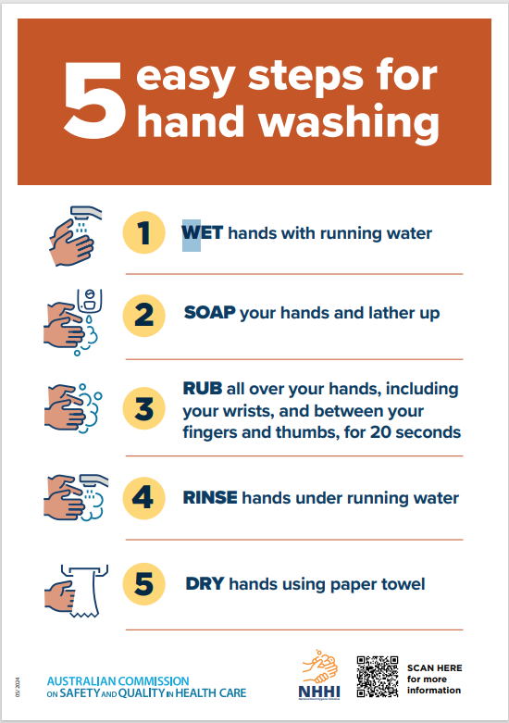

#### Handwash and Handrub Protocols for Procedural Hand Hygiene

For Hand Hygiene moments where a surgical scrub is not required the following Handrub and Handwash procedures apply:

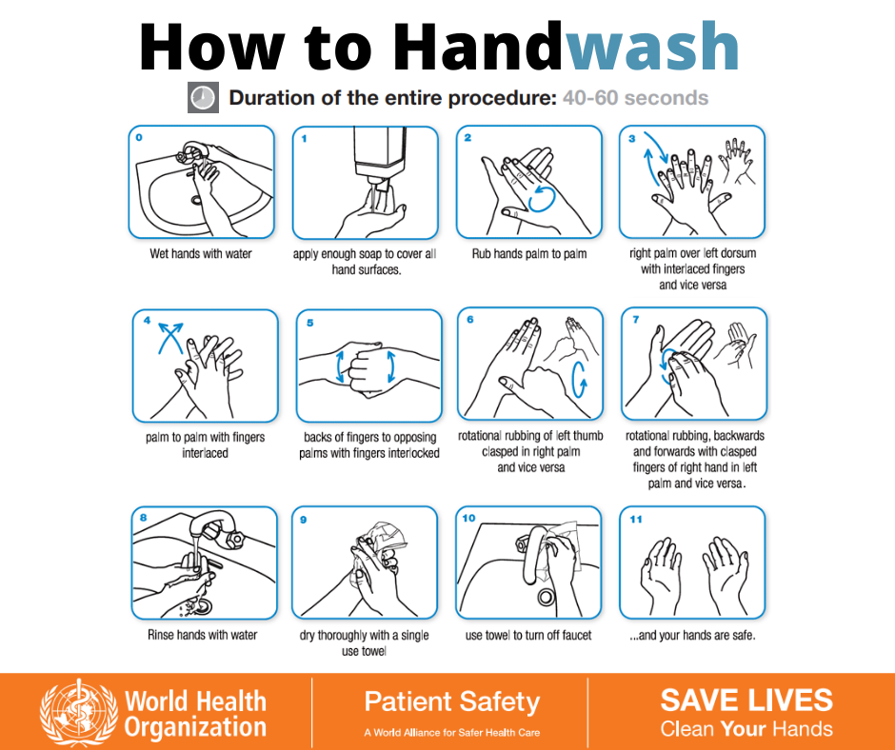

Source: [nhhi hand wash - Search Images (bing.com)](https://www.bing.com/images/search?view=detailV2&ccid=qu6juBSq&id=C3F34751A135D749DCDE50581D3C6F029B9C2C12&thid=OIP.qu6juBSqtpXT2o3mSO6ctAHaGN&mediaurl=https%3A%2F%2Fstatic.wixstatic.com%2Fmedia%2Ff18eaa_03df83fb25a84ab586ab59b6cd637bb8~mv2.png&exph=788&expw=940&q=nhhi+hand+wash&simid=608051989992768872&form=IRPRST&ck=06C153DAEBE1DC6F9529D860A50FAC8D&selectedindex=0&itb=0&qpvt=nhhi+hand+wash&cw=1375&ch=760&ajaxhist=0&ajaxserp=0&pivotparams=insightsToken%3Dccid_3og5Rg4v*cp_1FA8B0DD098768298CA0D315F05725B4*mid_360202CB7CE242E0FAF4D20E363B86F0B89A3E69*simid_607997499747541581*thid_OIP.3og5Rg4vjcyYP3a6Ix1mHAHaGN&vt=0&sim=11&iss=VSI)

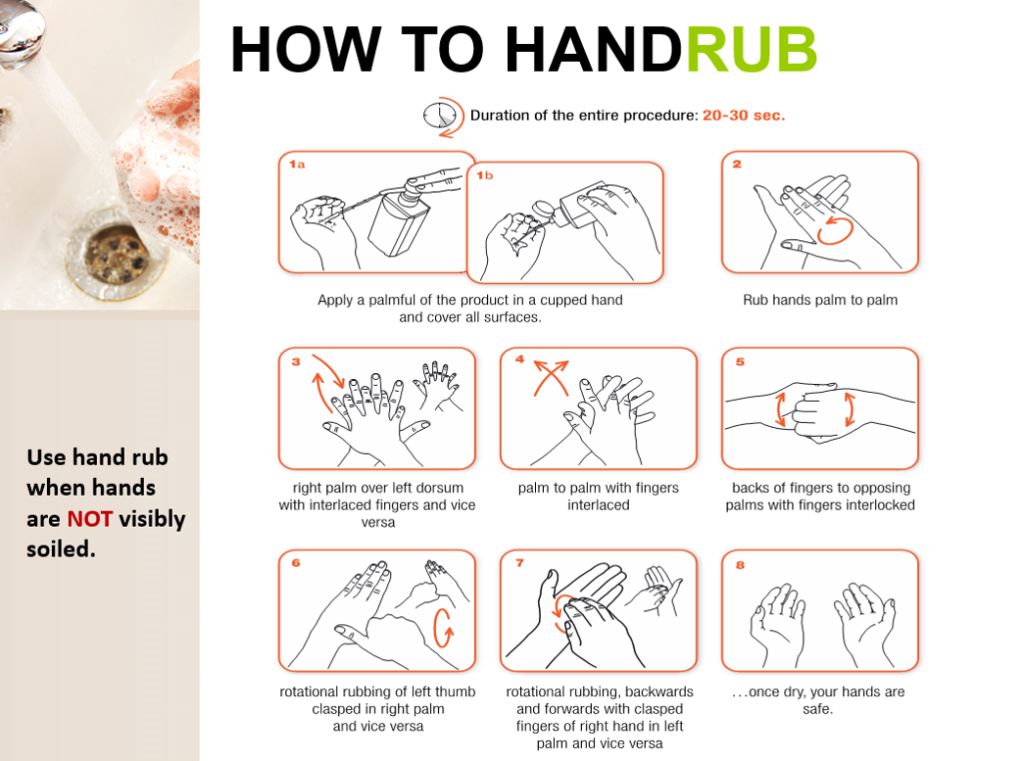

#### Source: [nhhi hand rub procedure - Search Images (bing.com)](https://www.bing.com/images/search?view=detailV2&ccid=RLUL6C7b&id=284A3CE0D759ED2895646AF79D88AD2525521C39&thid=OIP.RLUL6C7bjEHuSM1621l3RAHaFh&mediaurl=https%3A%2F%2Fcethatmatters.com%2Fwp-content%2Fuploads%2F2022%2F04%2F5-768x573.png&exph=573&expw=768&q=nhhi+hand+rub+procedure&simid=607999157602555123&FORM=IRPRST&ck=3DC004C87423566EA42ED157ECE2A4FC&selectedIndex=22&itb=0&qpvt=nhhi+hand+rub+procedure&cw=1375&ch=760&ajaxhist=0&ajaxserp=0)

#### Standardised Surgical Hand Scrub and Hand Rub Protocols

*As per guidelines: Australian College of Perioperative Nurses Ltd (ACORN). The New ACORN Standards: Volume 3 – 2023 Standards for Safe and Quality Care in the Perioperative Environment (SSQCPE) for Organisations. Adelaide, South Australia: ACORN; 2023:* **‘Surgical hand antisepsis, gowning and gloving’ (SHAGG) Standard: the following surgical scrub procedural guidelines apply.**

* Traditional surgical hand scrub is performed using Microshield® PVP Povidone-Iodine OR Microshield® 4 Chlorhexidine (or other CHS approved antimicrobial solution
* First scrub of the shift is a **five (5) minute scrub**, which involves cleaning under the nails with a nail pick and cleaning hands and arms (to 2.5cm above the elbows) with a sponge brush
* Subsequent and consecutive scrubs of the shift are **three (3) minutes** in duration and do not require the nails to be cleaned unless visibly soiled
* Clinicians shall not change to a surgical hand rub process after commencing the list with a surgical hand scrub
* **Note:** To ensure clean to dirty approach, hands should be kept above the elbow level allowing water to run from a clean to dirty area
* Arms are washed using a circular motion starting at the hands and moving to above the elbow
* Refrain from returning to the hands once the elbows have been reached
* Bristles of scrub brushes shall not be used

#### Alcohol-based surgical hand rub using Skinman 90

When performing a surgical hand rub, the clinician shall only perform a hand wash prior to hand rub procedure if hands are visibly soiled, including nails (utilise a nail pick). A non-antimicrobial soap should only be used

Dry skin thoroughly and apply Skinman 90 according to the following manufacturer instructions for use

Don a mask and protective eyewear before any surgical hand antisepsis

1. Dispense several pumps of Skinman 90 into your cupped hand and smear the solution over all surfaces of both hands and wrists.
2. Dispense several pumps of Skinman 90 into your cupped left hand, dip the fingertips of your right hand into the solution in your left hand to decontaminate underneath your nails
3. Smear the remainder of the solution in your left hand in circular motions up your right arm (from wrist to your elbow) for 10-15 seconds
4. Dispense several pumps of Skinman 90 into your cupped right hand, dip the fingertips of your left hand into the solution in your right hand to decontaminate underneath your nails
5. Smear the remainder of the solution in your right hand in circular motions up your left arm (from wrist to your elbow) for 10-15 seconds (note: it should take 30 seconds total time to reach this point)
6. Dispense several pumps of Skinman 90 into your cupped hand and continue rubbing over all surfaces of your hands and wrists for 60 seconds. If the solution dries out before 60 seconds apply more solution.
7. Proceed to donning sterile personal protective equipment (PPE).

#### 5-minute Surgical Hand Scrub

**Step 1: Duration one (1) minute**

1. Open and prepare, a nail cleaner and scrub sponge for later use

2. Rinse hands and forearms with running water, apply antiseptic solution to 2.5cm above the elbow

3. With hands under running water, use nail pick to remove debris from underneath the fingernails

4. Dispose of nail pick in bin

**Step 2: Duration two (2) minutes**

1. Apply antiseptic to scrub sponge and wash all surfaces of hands and forearms working from the nail beds and between fingers before proceeding to wash the forearms, to the level of the elbows, using circular hand motions. Apply more antiseptic solution if necessary

2. Dispose of scrub sponge/brush in bin

3. Rinse hands and forearms

**Step 3: Duration two (2) minutes**

1. Hands and forearms are washed again using the principles and procedures above, but stopping at mid forearm

2. On completion rinse the hands and forearms

3. Apply scrub solution to your hands only. Rub over all surfaces of hands, nailbeds and between fingers

4. Hands and forearms are rinsed thoroughly

#### 3-minute Surgical Hand Scrub

**Step 1: Duration two (2) minutes**

1. Rinse hands and forearms with running water, apply antiseptic solution to 2.5cm above the elbow

2. Apply additional antiseptic solution and wash all surfaces of hands and forearms working from the nail beds and between fingers before proceeding to wash the forearms, to the level of the elbows, using circular hand motions. Apply more antiseptic solution if necessary

3. Rinse hands and forearms

**Step 2: Duration one (1) minute**

1. Hands and forearms are washed again using the principles and procedures above, but stopping at mid forearm

2. On completion rinse the hands and forearms

3. Apply scrub solution to hands only. Rub over all surfaces of hands, nailbeds and between fingers

4. Hands and forearms are rinsed thoroughly

#### Hand Drying

After any hand wash procedure, it is important to dry hands and arms prior to donning a surgical gown.

The steps are as follows:

**Step 1:**

* 1. Remain at the sink until the hands and arms are drip dry
  2. Approach gown trolley and grasp sterile towel by one corner. Do not drip water on to gown trolley.

**Alert**

Skin breaches (e.g. cuts, abrasions, rashes) provide a pathway for the potential transmission of infection from staff member to patient and vice versa. All care should be taken to protect the integrity of the skin when performing a surgical scrub

Recommendations

* Choose the scrub solution that causes minimal harsh effects on the skin
* Hands are moisturized regularly with a water-based lotion provided by the Health Care Facility
* The same surgical scrub solution shall be used throughout the day to avoid interruption to the cumulative effect of that particular solution
* Water pressure is adjusted to prevent wetting of Perioperative attire, possibly rendering the scrub gown unsterile by strike-through

3. Step back from gown trolley, with arms outstretched allow the towel to unfold. Do not allow towel to touch unsterile scrub attire

**Step 2:**

1. Using one half of the towel, pat dry one hand, moving down the forearm to the elbow in a circular motion, without returning to the hand
2. Grasp the opposite half of the towel and release the contaminated half. Using the untouched half of the towel, pat dry the other hand, moving down the forearm to the elbow in a circular motion, without returning to the hand
3. Drop the towel into the appropriate container (linen skip or waste bin) being careful to avoid contamination from further handling of the towel. Hands remain above waist level and away from unsterile scrub attire at all times

* If using disposable gowns and hand towels, step two is performed using one hand towel per hand/arm and disposed in non-clinical waste

## Attachment 2 - Use of other PPE

#### Clinical Environment

Additional PPE (e.g., eye protection, masks) should be worn according to standard precautions to reduce the risk of blood and body fluid exposure to the clinician.

Maximum barrier precautions (e.g., sterile gown and gloves, and sterile drapes) may be required during highly invasive procedures (e.g., central venous catheter insertion) to reduce the risk of HAI for patients.

#### Surgical/Restricted Area Environment

The surgical gown is designed and presented in a manner that enables its application using non touch aseptic technique.

The gown is:

* Made of materials that comply with Australian Standards and provide an effective barrier (i.e. prevent strikethrough)
* Fastened by an unscrubbed member of the team to ensure it is held closed at the back
* ‘Turned’ and secured by tapes at the side as soon as is practicable before approaching the sterile field
* Care must be taken to ensure tapes do not drop below waist level – if this occurs the tapes are considered unsterile
* Considered sterile from mid chest to table level in front, and from the elbow to the glove tips
* Changed if contaminated during the procedure
* Removed before gloves to protect hands from contamination.

#### Additional Attire requirements

In addition to the above PPE requirements in the surgical environment, the following should be adhered to:

* + - Clean perioperative attire
    - All hand and arm jewelry is removed including rings, bracelets and watches (bare below the elbows)
    - All hair is fully covered including facial hair
    - Ears are covered

## Attachment 3- Aseptic Technique Risk Assessment Examples

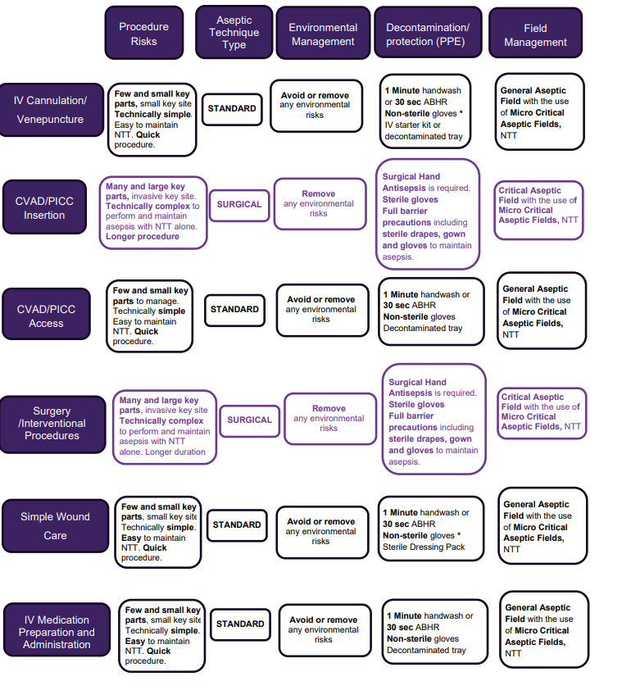

#### Other factors to consider in Aseptic Technique Risk Assessment

* + Please note: the above risk assessment examples are not intended to be prescriptive or exhaustive.
  + * Indicated above represents the typical glove of choice for the procedure however other risk factors may necessitate the more appropriate use of sterile gloves (for example, lack of confidence in maintaining non touch technique)
  + Always consider CHS Clinical Procedure Guidance Documents in conjunction with Risk Assessment (for example, CHS practice recommends management of dressing pack as a critical aseptic field with the addition of sterile gloves for procedures such as Blood Culture Collection and IDC Insertion. Refer to relevant Clinical Procedure)